

**Faculty of Engineering and Applied Science**

**SOFE 4590U Embedded Systems**

**Group 6 CRN 74020**

**Lab 2**

| **Name** | **Student #** |
| --- | --- |
| **Alexander Campbell** | **100703650** |
| **Atharshan Kennedy** | **100590243** |
| **Nicole Okeke** | **100769799** |
| **Tiwaloluwa Ojo** | **100700622** |
| **William Robinson** | **100751756** |

**Introduction:**

In this lab we gained practical experience in embedded development, specifically utilizing GPIO pins, programming in an embedded environment, and how breadboards interact with the Jetson TX2.

Utilizing the GPIO pins of the Jetson TX2 and given code, we were able to better understand how GPIO pins can be utilized in a wide range of uses. We also gained a better understanding of how to create programs that can use the Jetson TX2 GPIO pins through the troubleshooting of given code, such as exporting them, setting their direction, etc. In addition to this, being able to examine the connections on the breadboard and the Jetson TX2 showed us how circuits are set up to interact with embedded systems.

**Procedure:**

In this experiment we were to utilize the given code and library to turn an LED light on and off 5 times and then be able to control it with a button. The breadboard and Jetson TX2 had its hardware setup so we moved onto implementation. We utilized two different computers in order to complete the lab. We first ssh’d into the Jetson TX2 environment through Visual Studio and brought the files jetsonGPIO.c, jetsonGPIO.h, gpio_button.c, and any necessary files from the provided Github repository into the Jetson TX2 environment.

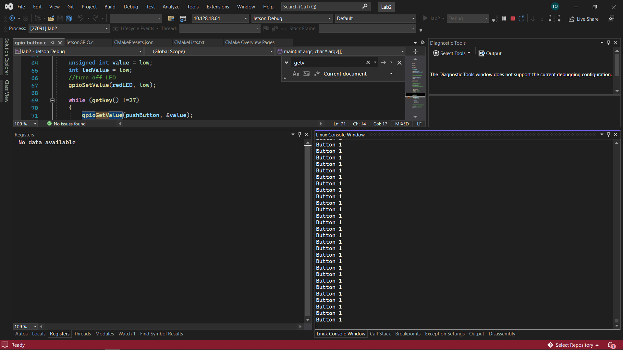

In the Putty interface, we installed the libraries that were downloaded in the previous step, set our user permissions and ran the post install script that was needed to run the application.

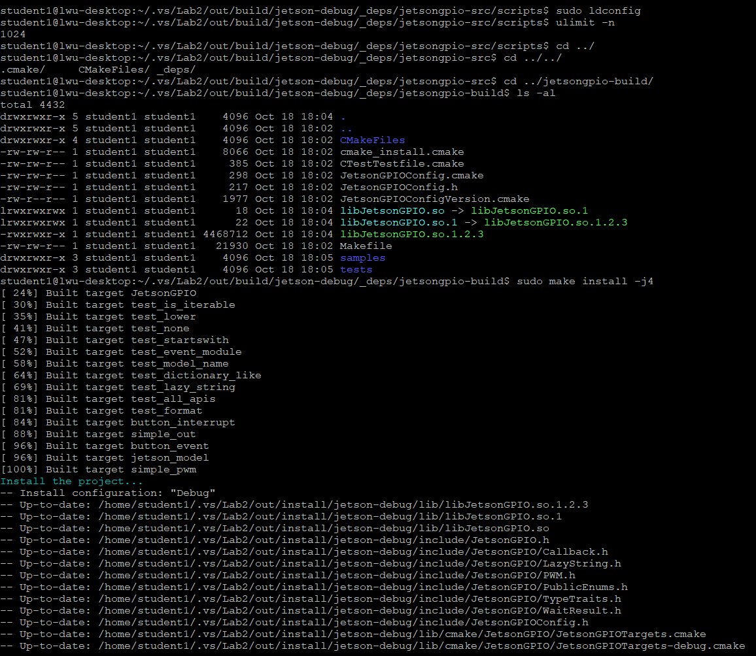

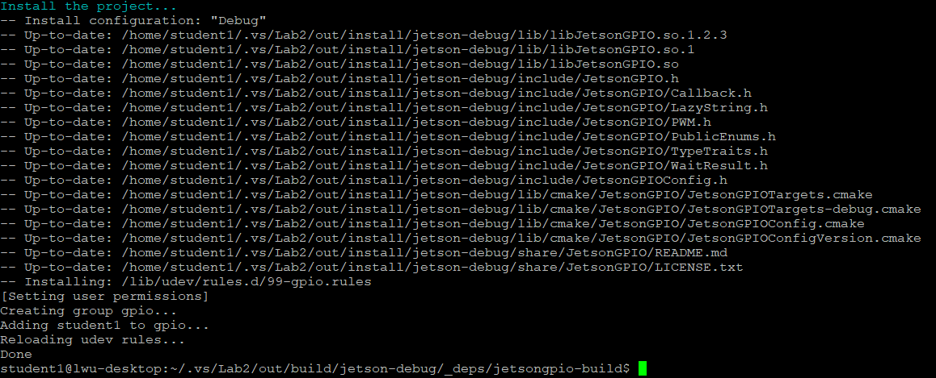Then in the Visual Studio interface we compiled and linked our code using a custom CMake file that also had the needed permission configurations. The earlier step in which we set user permissions allowed us to complete this.

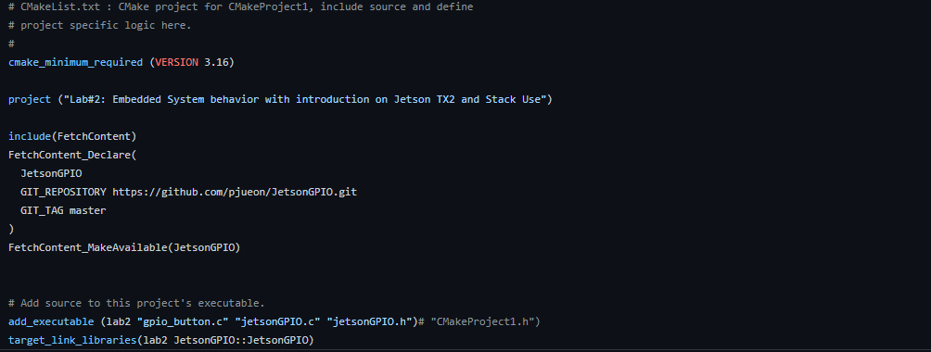

Finally, the code successfully compiled and built, flashing the LED 5 times and additionally whenever we pressed the button as seen below. We could also view the output printing Button 1 when the button was held down.

